**Project Report**

***On***

**“Android Chat Application:-AirTalk”**

**Submitted by**

Prasad S. Mahabare

Aditya A. Sahasrabudhe

**Under the Guidance of**

Prof. Mrs. M.P. Fatangare

**In partial fulfilment of**

**Diploma in Information Technology**

March 2016



**DEPARTMENT OF INFORMATION TECHNOLOGY**

**MAEER’S MIT POLYTECHNIC**

**PUNE – 411038**

Affiliated to



**MSBTE**

**Acknowledgement**

This is a great pleasure & immense satisfaction to express my deepest sense of gratitude &thanks to everyone who has directly or indirectly helped me in completing my project work successfully.

I express my gratitude towards project guide and Prof. Mrunal P. Fatangare, Head of Department of Information Technology, MAEER’S MIT Polytechnic, Pune who guided & encouraged me in completing the Project work in scheduled time.

I would like to thank our Principal, Prof. Rohini. S. Kale, for allowing us to pursue my project in this institute. I also thank to Prof. K. H. Kolambe, Project-in-charge, for her guidance and for being a constant source of support. I also thanks to lab assistants for their technical support. No words are sufficient to express my gratitude to my family and friends for their unwavering encouragement.

Prasad S. Mahabare(Roll No.19)

Exam Seat No_______

Aditya A.Sahasrabudhe(Roll No.21)

Exam Seat No_______

**ABSTRACT**

This Project deals with creativity and invention of chat services. Here the user is intimated about any information/notification.

The industry as an organization has lot of valuable information which can be provided to the industry, such as release of results ,enrolment information , Industry notification , opportunities and alerts etc. by sending message on the wall. This reduces the manual work to much extent. Here the message can be sent by the Server(Manager/anyone with Authority) to the number of client (employees under that authority) connected to it. Connected client is only allowed to make use of this service.

After understanding the existing Chat Apps and understanding the need for developing a new system different people involved in the related activities have been consulted. The data needed for the study has been collected from the company records.

Objectives of the Proposed System are

* To minimise the size of the app
* To make easy and simple to use
* To make chat Session faster
* To provide backing up the chat session and restore

By making use of Android based Chat Application makes it easy and free to use. The app helps the user to see chat records with the details of the chat. The record data is maintained and backed up such a way that data is not loss. The speed of the System could also inscrese.

**CHAPTER: 1**

**1. INTRODUCTION**

* 1. **Motivation:-**

The basic idea behind developing this project was to provide application i.e. app for the people who works in industry. It is tedious job to contact employees through the existing apps that is facebook , whatsapp or twitter. It is difficult because we use it for social purpose and not for industry use.

We need to contact our colleagues for many purposes when we aren’t in condition of having a meeting. And the main and most important factor of the software is that it includes android system which will provide notifications on the mobile phone or smart phone of the user. As soon as the message is posted the user who is connected to the server chat app receives message right on the phone so it becomes user friendly and useful for use.

After understanding the existing apps and understanding the need for developing a new app different people involved in the related activities have been consulted . The data needed for the study has been collected from company records and websites.

Existing system/apps includes lot of features to maintain all the chat session and has really being complex to understand and difficult to implement.

This will create a positive energy between people and would be a greater profit if the application is shared among most of the trending websites now a days. More Fundamental obstacles in the mind of the users will be cleared efficiently. Over the Last Decade there where not such application where people can communicate will each other and have a talk on that basis also.

As Observed nowadays technological improvements and currently stagnating because of less network availability , this application will also overcome the problem of long duration downloading of the application.

The Principle of this application is separated into 2 parts firstly the user interface and the application logic.Android Chat application enables you to connect to any computer’s, tablet ,smart phone etc. across the internet which is powered by Google’s Android Platform.

**1.2. Literature survey:-**

This project is a challenge for us which have been referenced to us

by different websites and many kinds of books related to our field.

This is one of the best instant messaging applications to stay connected to infinite people, around the world.

With all necessary features and real time chatting experience, you only require to registering to the services and start for the chat.

The References for all the new project (idea) came through various sites as follows:-

1. http://quickblox.com/developers/Android_XMPP_Chat_Sample
2. https://www.google.co.in/search?

q=android+chat&espv=2&biw=1280&bih=879&source=lnms&tb

m=isch&sa=X&ved=0ahUKEwj6zbyEpJ7KAhXNVI4KHRTxBp

gQ_AUIBigB&dpr=1.

1. https://www.youtube.com/watch?v=TDU6B687NdE
2. Advanced Android for Games (Book)
3. https://www.android.com/**(Review taken for the GUI of our Chat application *POSILIVE).***
4. http://developer.android.com/develop/index.html (What is android ? A sample project video)

**1.3. Need:-**

Our basic aim to build the chat application is to provide minimum difficulties to the user and to maximise our product in the world of market.

It is very easy , simple and very less in size which can be transferred to any smartphone easily.

The need to make this application arised because our application is most unique and very simple than other chat application which are trending in the market.

Now we are in the stage where all things are becoming digitalize i.e (Make in India) so this is the additional thing which we have added in that criteria and creating a charge in the people’s mind to spread the chat application world-wide.

**Table of Contents**

|  |  |  |
| --- | --- | --- |
| **Sr. No** | **Topic Name** | **Page no** |
| 1 | Introduction-  1.1 Motivation  1.2 Literature survey  1.3 Need |  |
| 2 | Proposed Work-  2.1 Problem Definition  2.2 Final objective  2.3 Constraints  2.4 User requirements  2.5 life cycle of the project  2.6 feasibility study  2.7 Project Plan (schedule) |  |
| 3 | Project Design-  3.1 Hardware software requirements,  3.2 Modules description  3.3 Algorithms |  |
| 4 | Implementation-  4.1 Necessary source code of project  4.2 Testing ( Sample Test cases) |  |
| 5. | User Manual |  |
| 6 | Advantages(features) and Limitations of the project |  |
| 7 | Future Development |  |
| 8 | Conclusion |  |
| 9 | References |  |

**CHAPTER: 2**

**PROPOSED WORK**

**2.1. Problem Definition:-**

* In the era where every aspect of our life is digitalize from, documents to online.
* So we are making an app which is easy to use, simple to understand.

**2.2. Final objective:-**

* It will display the UI of the server side & the client side and when the message is send it will display the time and the date with the message .
* The final side of the project will be that the user can back up the messages on his registered mail as well as the application can too restore the earlier messages if the application is abruptly un-installed or forcely stopped.

**2.3. Constraints:-**

* Our project is based on android operating system.
* So android devices are needed.
* Android version needed above JellyBean.
* We use android studio for development.
* Android devices must be connected in same Home Network.

**2.4. User requirements:-**

An android chat application that is simple , easy , maintainable and secure to use in Industry.

**2.5. Life cycle of the project:-**

**2.6. Feasibility study:-**

Time Feasibility: - 4 months

Cost Effectiveness:- 10000/-

**2.7. Project Plan:-**

|  |  |  |
| --- | --- | --- |
| **Name** | **Work** | **Duration (in Days)** |
| Prasad S. Mahabare. | Literature Survey (partial) | 05 |
|  | User Requirement (partial) | 10 |
|  | Requirement Analysis (partial) | 15 |
|  | Design (partial) | 20 |
|  | Algorithm (partial) | 20 |
|  | Code (partial) | 30 |
|  | Testing (partial) | 20 |
| Aditya A. Sahasrabudhe. | Literature Survey (partial) |  |
|  | User Requirement (partial) |  |
|  | Requirement Analysis (partial) |  |
|  | Design (partial) |  |
|  | Algorithm (partial) |  |
|  | Code (partial) |  |
|  | Testing (partial) |  |

**CHAPTER: 3**

**PROJECT DESIGN**

**3.1 Software requirements:-**

Hardware Requirements:- Mobile Device with minimum android version of JellyBean

Software Requirements:- 1.JAVA

2. My SQL

3. Android Studio

* 1. **Modules description:-**

1. Software Module:-
   * + Install Android Studio1.5.1
     + Install MySQL
     + Created First Graphical User Interface for both apps (Client and Server).
     + Coding
     + Testing
   1. **Algorithms: 1.**At Server Side

* Start Application.
* Give the Name of the user.
* After That Chat Session will be Started & specific IP address will be upright down after typing the name.
* Stop

2.At Client Side

* Start the client Application.
* Give the name of the user.
* Type the Ip Address that was specified by the Server.
* Then it will generate the identity of ip address ,weather the address is right or wrong.
* If right then the application will retrieve the chat page.
* If the ip address is wrong then it will generate the exception.

**3.4 DFD :-**

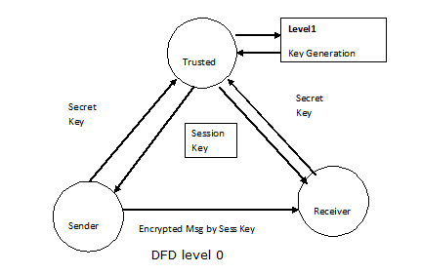

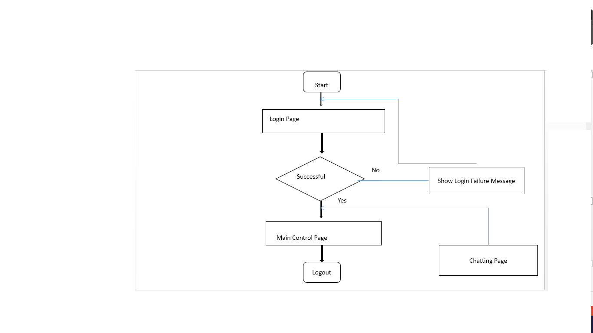**Flow-Chart:-**

* 1. **UML Diagrams:-**

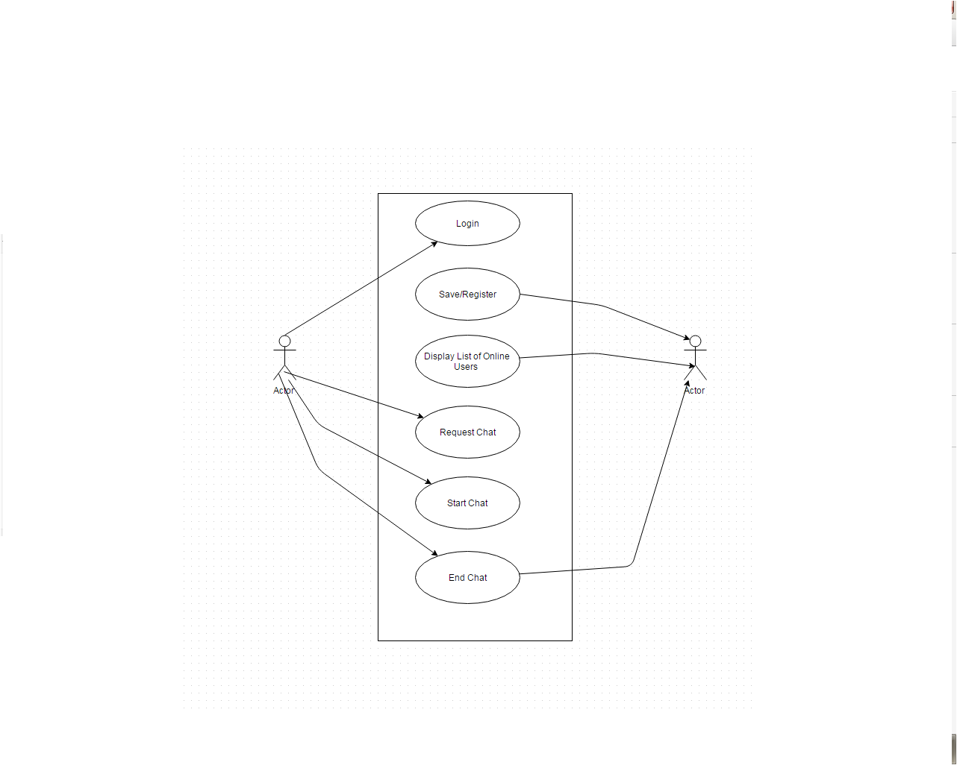

**Deployment Diagram**

**Class Diagram**

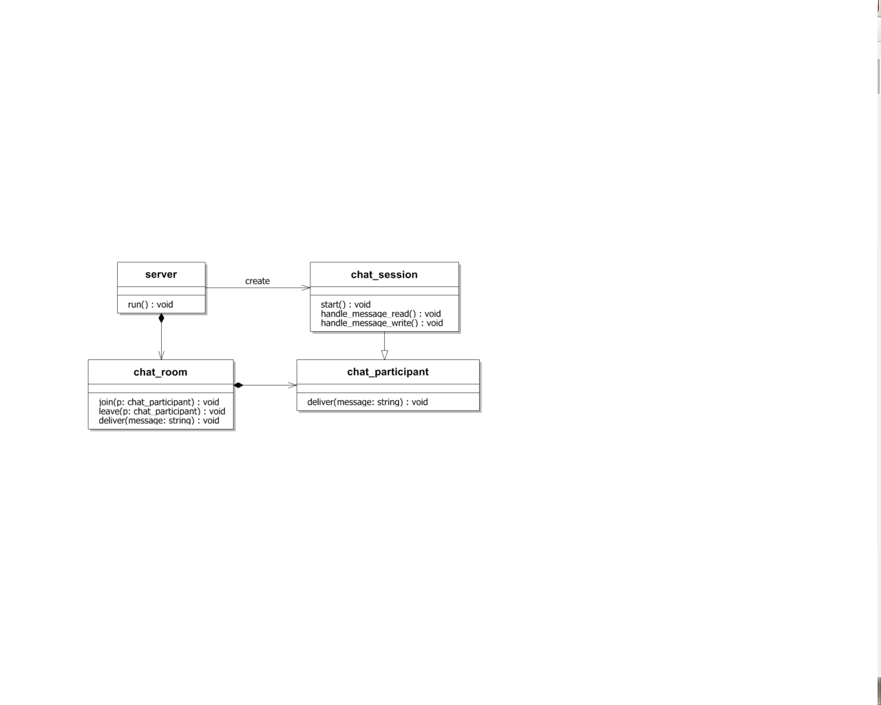

**Component Diagram**

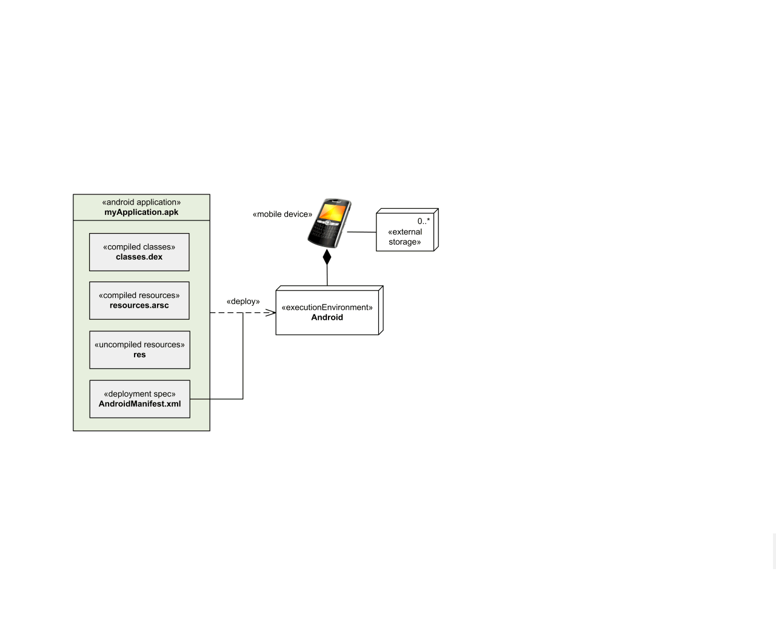

**Sequence Diagram**

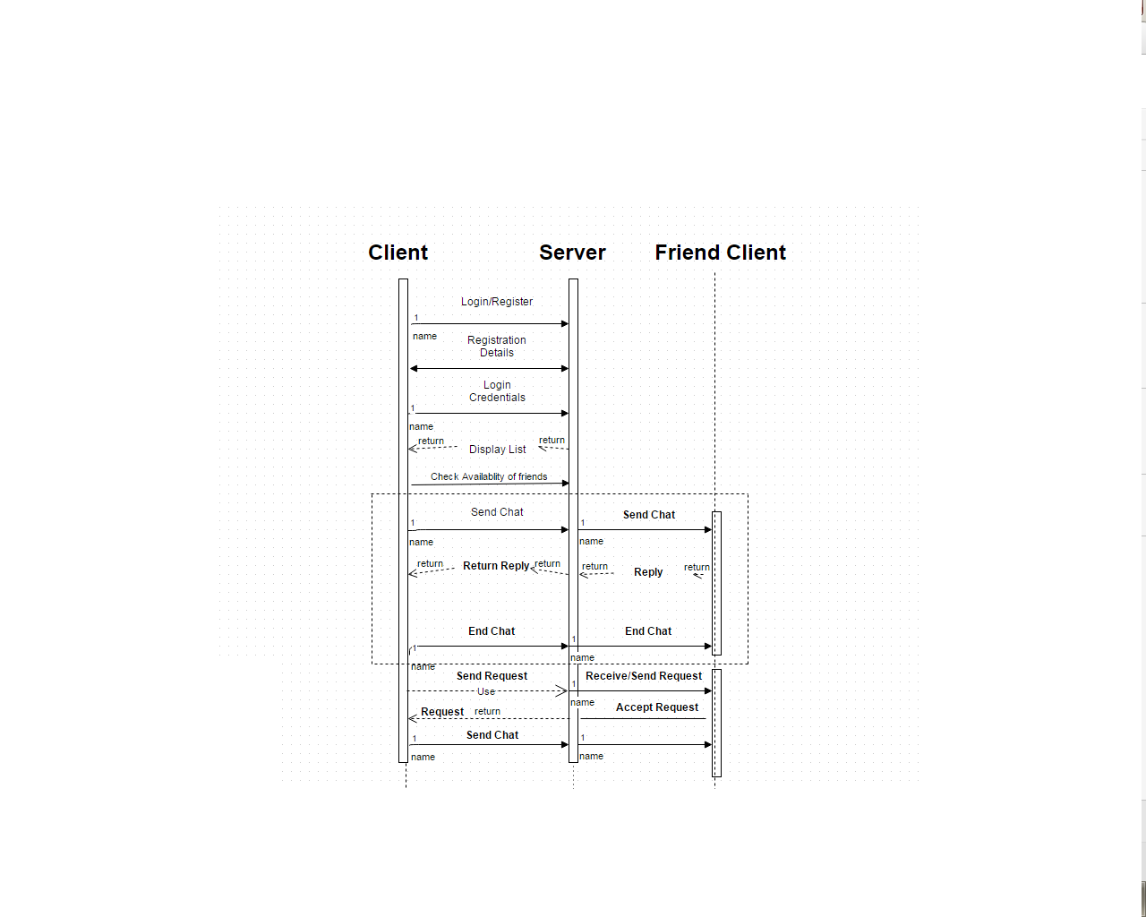

**CHAPTER: 4**

**IMPLEMENTATION**

**4.1 Necessary source code of project:**-

**4.2 Testing (Sample Test cases)**:-

|  |  |  |  |  |  |  |
| --- | --- | --- | --- | --- | --- | --- |
| **Case ID** | **Description** | **Test Item** | **Pre Condition** | **Steps need to be done** | **Expected result** | **Result** |
| 1 |  |  |  |  |  | Pass |
| 2 |  |  |  |  |  | Pass |
| 3 |  |  |  |  |  | Pass |
| 4 |  |  |  |  |  | Pass |

**CHAPTER: - 5**

**USER MANUAL**

**5.1 Manual:-** 1**.** Start the Application

2.Type the specified ip address

3.then click on join the server

4.start the client application

5.type the same ip as reffered on server side.

6.join the session

**CHAPTER: - 6**

**ADVANTAGES AND LIMITATIONS OF THE PROJECT**

**Advantages:-**

* Less time consumption.
* More accurate.
* Reduction of Complexity.
* Easy access to any mobile user with Android Platform.
* Latest technologies.
* Instance access.
* Eco-friendly.

**Limitations:-**

* Max 5 Users can chat at a time.
* No Video Chatting.
* No Voice Call.

**Future Development**

* We can Increase the number of user’s which can chat at a time.
* We can add Various Chat Themes.
* We can add Various Profile.

**CONCLUSION**

**REFERENCES**

**WebSites:-**

* http://www.instructables.com/id/Arduino-and-RFID-from-seeedstudio/
* http://www.adafruit.com/products/1651
* http://computers.tutsplus.com/tutorials/how-to-add-an-sd-card-data-logger-to-an-arduino-project--cms-21713

**Books:-**

**Research papers:-**